# Week 9 Assessment:

1. What is draft, and for what manufacturing purpose is it mainly used?

*Draft is when you add a small angle (1-3°) to any surface so that it may be properly manufactured using Plastic Injection Molding processes. The draft angle is measured between the the surface and the direction of pull.*

1. Why are small radii common in parts that have been designed for plastic injection molding?

*Adding small radii to sharp edges allows for the plastic to “flow” better during the molding process, and facilitates easier removal of the part from the tooling after molding.*

1. What is a “Split” feature?

*It is when you cut a single part into multiple parts using a surface or plane.*

1. Explain a typical use of a Variable in Onshape.

*A Variable is used to establish a design parameter, for example the thickness of a plastic part, that may be referenced throughout the design; in multiple features and parts.*

1. Explain what is going on in the “thickness” entry of the dialog box below:

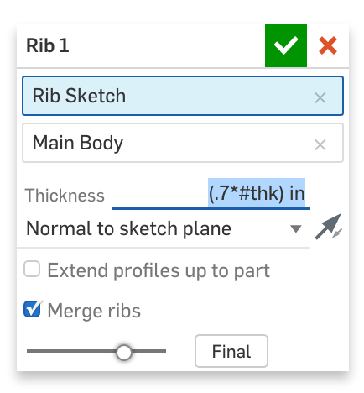

*We are defining the thickness of the rib feature as an expression, 0.7 X “thk” inches, where “thk” is a previously defined variable in our model.*